**“Air Touch”**

***A***

***Project Report***

*submitted in partial fulfillment of the*

*requirements for the award of the degree of*

**BACHELOR OF TECHNOLOGY**

**in**

**COMPUTER SCIENCE & ENGINEERING**

**by**

|  |  |
| --- | --- |
| **Name** | **Roll No.** |
| **Devansh Dutta** | **R2142210266** |
| **Nitish Gupta** | **R2142210541** |
| **Ahhan Chhetri** | **R2142210064** |

***under the guidance of***

**DR. Archana Kumari**



**School of Computer Science**

**University of Petroleum & Energy Studies**

**Bidholi, Via Prem Nagar, Dehradun, Uttarakhand**

**Month – 2024**

**1**

**CANDIDATE’S DECLARATION**

We hereby certify that the project work entitled **“Air Touch”** in partial fulfilment of the requirements for the award of the Degree of BACHELOR OF TECHNOLOGY in COMPUTER SCIENCE AND ENGINEERING with specialization in AIML and submitted to the Department of School of Computer Science, University of Petroleum & Energy Studies, Dehradun, is an authentic record of our work carried out during a period from **August**, **2024** to **December**, **2024** under the supervision of Dr. **Archana kumari.**

The matter presented in this project has not been submitted by us for the award of any other degree of this or any other University.

This is to certify that the above statement made by the candidate is correct to the best of my knowledge.

Date: 06-12-2014 **Dr. Archana Kumari**

Project Guide

2

**ACKNOWLEDGEMENT**

We wish to express our deep gratitude to our guide **Dr. Archana Kumari**, for all advice, encouragement and constant support she has given us throughout our project work. This work would not have been possible without his support and valuable suggestions.

We are also grateful to Dean SoCS UPES for giving us the necessary facilities to carry out our project work successfully. We also thanks to our Course Coordinator, Dr. Vijendra Singh and our Activity Coordinator Dr. Pragya Katyayan for providing timely support and information during the completion of this project.

We would like to thank all our **friends** for their help and constructive criticism during our project work. Finally, we have no words to express our sincere gratitude to our **parents** who have shown us this world and for every support they have given us.

|  |  |  |  |
| --- | --- | --- | --- |
| **Name** | **Nitish Gupta** | **Devansh Dutta** | **Ahhan Chhetri** |
| **Roll No.** | **R2142210541** | **R2142210266** | **R2142210064** |

**3**

**ABSTRACT**

This overview looks at virtual mouse technology, which uses techniques like gesture recognition to replace conventional physical mice with digital counterparts. With a more flexible and intuitive input technique, virtual mice seek to improve accessibility and user interaction. This introduction goes over the fundamentals of virtual mice, examines some of the present applications, and talks about their possibilities in the future. Accuracy, timeliness, and software integration are emphasized, underscoring the technology's ability to change user interfaces and enhance digital accessibility.

**4**

**TABLE OF CONTENTS**

**S.No. Contents Page No**

1. **Introduction 1**
2. **System Analysis 2**
   1. Existing System 2
   2. Motivations 3
   3. Proposed System 3
   4. Modules 4
3. **Implementation 5**
   1. Path tracing using a Cartesian Co-ordinate System 5
   2. Scenarios 6
   3. Algorithms 7
4. **Output screens 8**
5. **Limitations and Future Enhancements** 9
6. **Conclusion 10**
7. **References** 11

5

1. **INTRODUCTION**

The Air Touch project is all about creating a new and efficient control of a computer without requiring a physical mouse. These systems use sophisticated technologies such as hand gesture recognition, allowing for interaction with the device through intuitive natural movements. By using sensors, cameras, and algorithmic software, the virtual mouse can trace the users' actions and translate them to commands on the screen without the need for traditional input devices.

This project can be highly useful for people with physical disabilities, working in environments where traditional mice are impractical, or simply seeking an alternative, hands-free method of interacting with their computers. The virtual mouse offers a convenient, user-friendly interface, enhancing accessibility and providing an alternative interaction model that could revolutionize human-computer interaction.

* Hinckley et al. (2006) emphasize the importance of advanced sensing methods like hand and gesture recognition, enhancing human-computer interaction [1]. Liu et al. (2013) highlight the role of touchless interaction techniques in improving accessibility for people with disabilities, offering alternative interaction methods [2]. Zhai et al. (2004) discuss the ergonomic benefits of virtual mice, reducing physical strain while maintaining functionality [3]. Igarashi et al. (2005) explore the adaptation of virtual mice to existing software environments, enabling smooth integration with current systems [4]. Elmqvist et al. (2011) identify trends in virtual input devices, indicating a shift toward more intuitive, gesture-based controls for a more immersive user experience [5].

The key objectives of the project are:

1. Gesture Recognition: Building a system that can decode hand movements or gestures to carry out actions such as moving the cursor, clicking, and scrolling.

2. Hands-Free Control: A means of reducing the dependence on physical input devices, which are convenient in many settings.

3. Accessibility: It is a solution for the users with mobility impairments who can operate computers better. 1

1. **SYSTEM ANALYSIS**

2.1. Existing System

Current systems primarily rely on traditional input devices like mouse and keyboards. While effective, these devices have limitations in accessibility and convenience, especially for users with disabilities or in certain environments.

2.2. Motivations

The Virtual Mouse is motivated by the need for:

* Accessibility for users with physical disabilities.
* Hands-free interaction in environments where traditional devices are impractical.
* Cost-effectiveness by minimizing the need for specialized hardware.

2.3. Proposed System

The proposed system replaces the traditional mouse with a gesture-based or sensor-driven interface, using cameras or motion sensors to track hand. It enables cursor movement, clicking, and scrolling without physical input devices.

2.4. Modules

1. Input Device Module: Captures gestures through camera.
2. Gesture Recognition Module: Interprets the input and identifies specific actions.
3. Mouse Action Mapping: Converts recognized gestures into mouse commands (cursor movement, click, etc.).
4. User Interface Module: Allows customization of settings (sensitivity, gestures).
5. Calibration Module: Ensures accurate gesture recognition for individual users.
6. **Implementation**
   1. Path Tracing using a Cartesian Coordinate System

In this system, the hand landmarks are tracked using the Mediapipe library, and their positions are mapped to a 2D Cartesian coordinate system on the screen. Specifically:

* The x and y coordinates of the hand landmarks are normalized relative to the screen resolution.
* The mouse cursor's position is determined based on the coordinates of the tracked hand (landmark 9 in the palm).
* The Controller.get_position() function calculates the cursor's new position by damping the movement to avoid jitter, ensuring smooth tracking.
  1. Scenarios

The system can handle various gestures and scenarios:

1. Fist Gesture: Simulates a mouse press (click and hold) when the fist gesture is detected.
2. Pinch Gesture (Minor/Major): Used for scrolling or system control (volume).
3. Two-Finger Gestures: Implemented for mouse right-click, double-click, or scrolling.
4. Palm Gesture: Inactive state where no control is executed.

Additional scenarios like controlling the brightness or volume are triggered by pinch gestures, while mouse movements and clicks are controlled by the finger states.

* 1. Algorithms
* Finger State Determination: The system determines whether each finger is open or closed by comparing distances between specific hand landmarks. This information is then encoded into binary values corresponding to specific gestures.
* Gesture Recognition: A function (get_gesture()) processes finger states and stabilizes the detected gesture using a thresholding mechanism to filter out noise and fluctuations.
* Pinch Control Algorithm: For pinch gestures, the pinch_control() function adjusts the volume, or scrolls the screen, based on the direction and magnitude of the pinch.
* Cursor Stabilization: The cursor position is adjusted based on the hand's movement, dampening the velocity to make the movement smooth and reducing the impact of minor fluctuations in hand tracking.

**4.Output Screens**

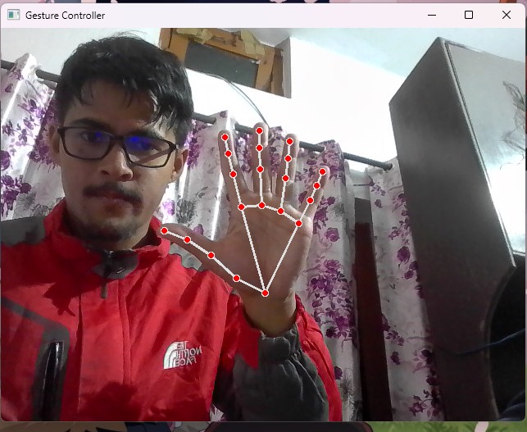

Fig. 4.1 :- Shows Hold Symbol

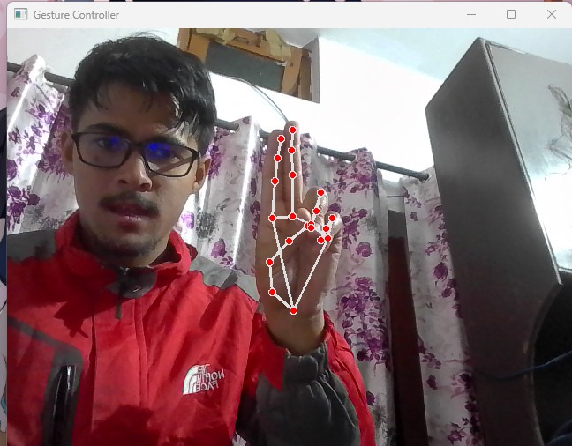

Fig. 4.2 :- Shows Double click Symbol

1. **Limitations and Future Enhancements**

Limitations:

* Gesture Accuracy: Affected by camera quality, lighting, and rapid hand movements.
* Single Camera: Limited accuracy with overlapping hands or gestures outside camera view.
* Finger Tracking: Difficulty detecting subtle or close finger movements.
* Noise and Interference: Fast or erratic hand movements may cause inaccurate detection.
* Multi-Hand Detection: Issues distinguishing actions between both hands simultaneously.
* Hardware Dependency: Relies on camera resolution and device performance.

Future Enhancements:

* Improved Recognition: Use advanced ML models for better accuracy with complex gestures.
* Multi-Camera Support: Enable 3D hand tracking with multiple cameras.
* Noise Reduction: Implement better algorithms for gesture smoothing.
* Real-time Calibration: Adaptive systems for personalized hand tracking.
* Custom Gesture Mapping: Allow users to define custom gestures.
* Cross-Platform: Expand compatibility across more devices and operating systems.

1. **Conclusion**

The reviewed literature indicates that virtual mouse technology holds promise for improving accessibility, ergonomics, and user interaction with computers. Key challenges include ensuring accurate gesture recognition, integrating with existing systems, and addressing ergonomic concerns. Future research should focus on combining sensing technologies, enhancing system compatibility, and exploring new applications such as AR to fully realize the potential of virtual mouse.

**References**

1. Hinckley, K., Morris, M. R., Baudel, A. A., & Lindh, R. W. (2006). Sensing Techniques

for Human-Computer Interaction. ACM Transactions on Computer-Human Interaction,

13(4), 340-372.

2. Liu, X., Hsieh, M. H., & Huang, T. J. (2013). Touchless Interaction Techniques for People

with Disabilities. Proceedings of the 2013 CHI Conference on Human Factors in Computing

Systems, 2315-2324.

3. Zhai, S., Kong, S. W., & Li, M. P. K. (2004). The Role of Virtual Mouse in Ergonomics.

International Journal of Human-Computer Studies, 61(5), 621-635.

4. Igarashi, T., Saito, A., & Kiyokawa, K. (2005). Adapting Virtual Mouse to Existing

Software Environments. Proceedings of the 2005 ACM SIGCHI International Conference on

Advances in Computer Entertainment Technology, 1-8.

5. Elmqvist, N., Schmidt, T. M. K., & Williams, J. M. (2011). Emerging Trends in Virtual

Input Devices. Journal of Computer Graphics, Multimedia & Animation, 15(2), 45-59.